TASK 1

1)Import libs

2)uploading and visualizing data

3)training the model

4)predicting

5)Cost = 0.07148238 \* Area + 0.8111407046647887

6) predict prices for new apartments from a new file

based on our model

7)create a new column in the file with new apartments and enter

the predicted prices there

8)save the file in Excel without the first

column

(below)

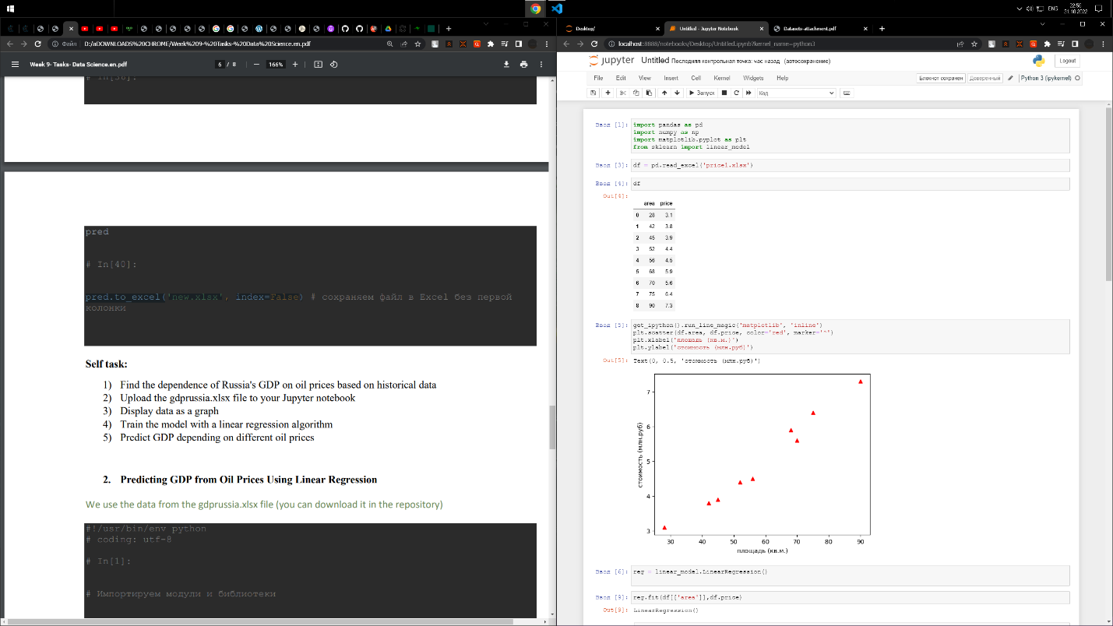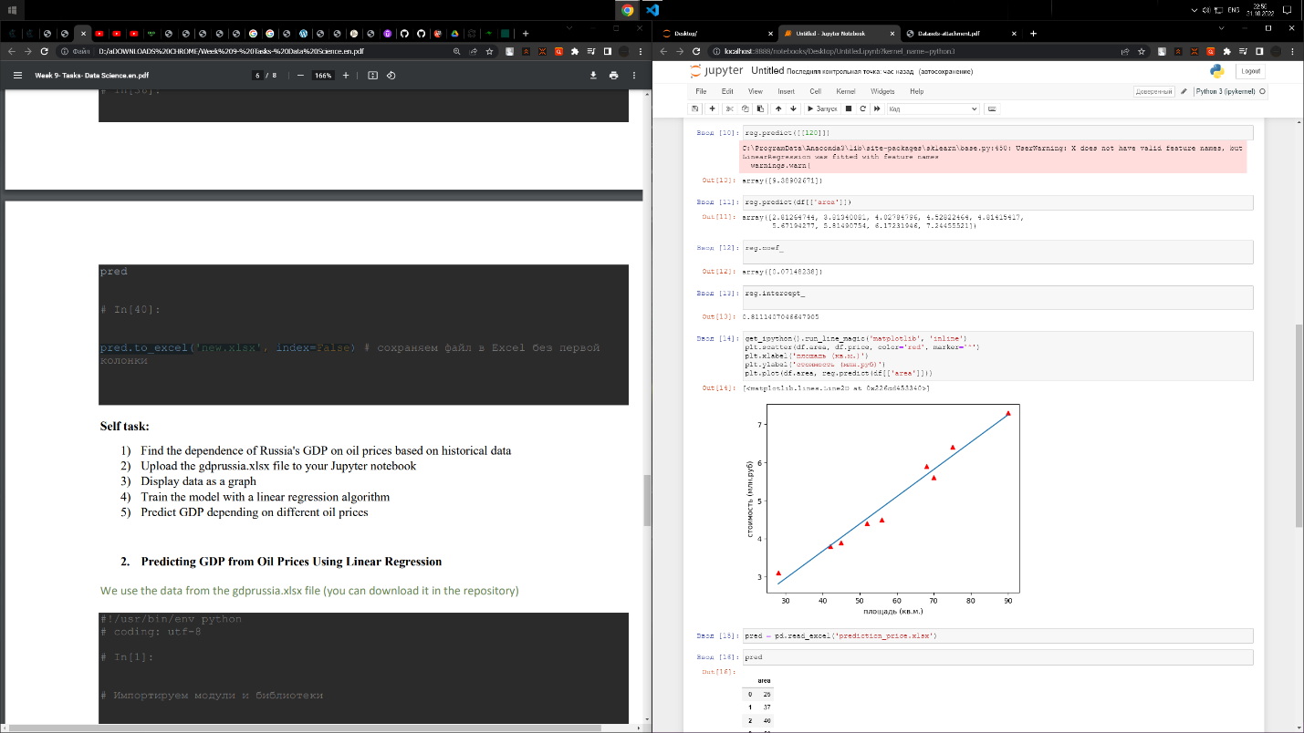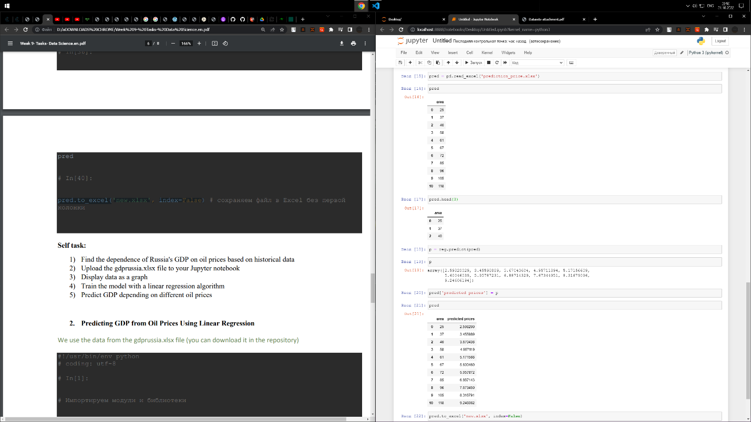

At the end we have new excel file with predicted prices

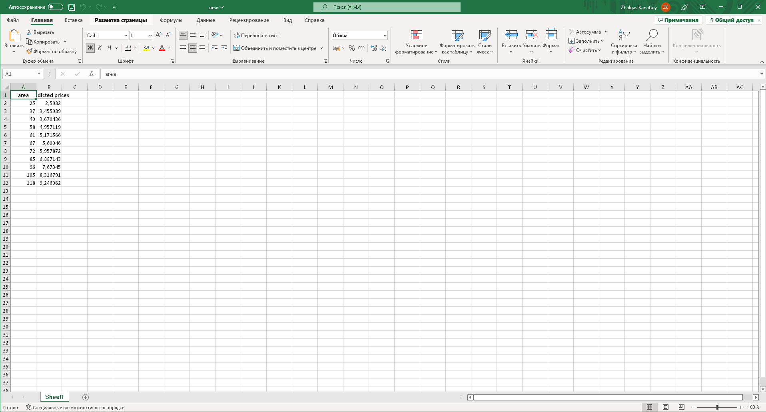

Task 2

Self-task:

1) Find the dependence of Russia's GDP on oil prices based on historical data

2) Upload the gdprussia.xlsx file to your Jupyter notebook

3) Display data as a graph

4) Train the model with a linear regression algorithm

5) Predict GDP depending on different oil prices

Code is below:

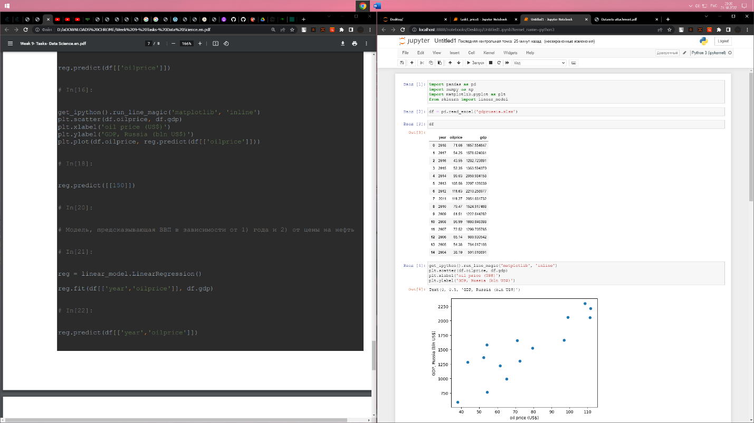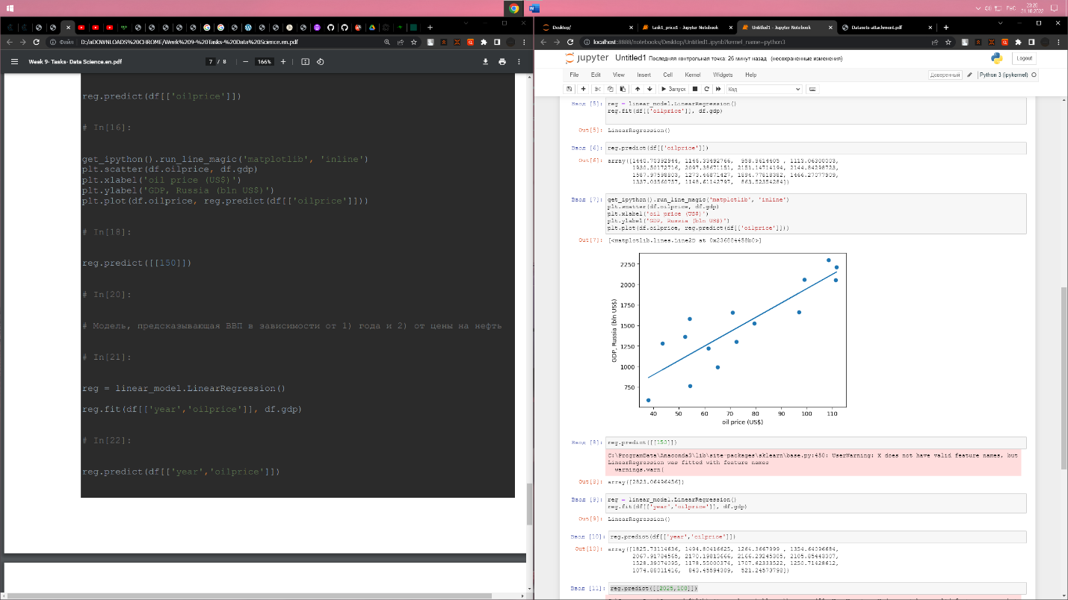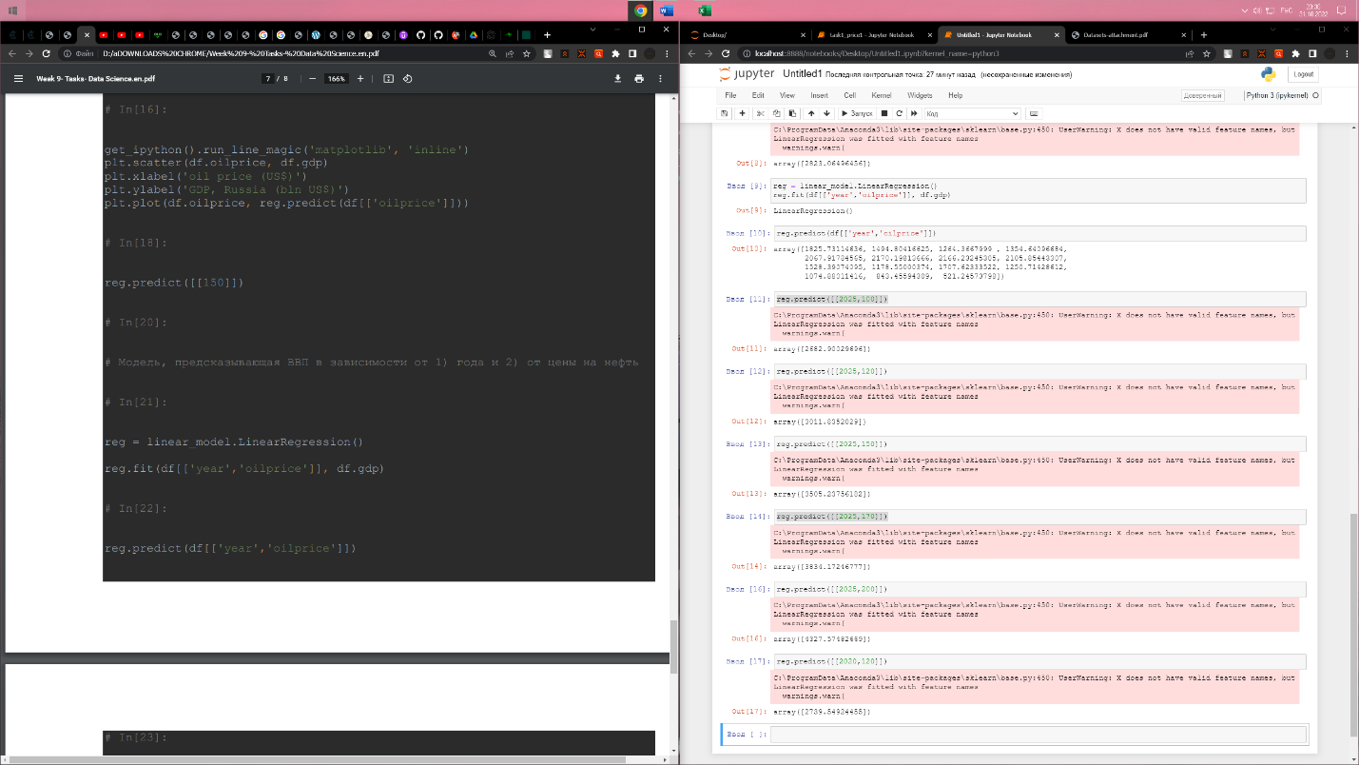

gdprussia.xlsx

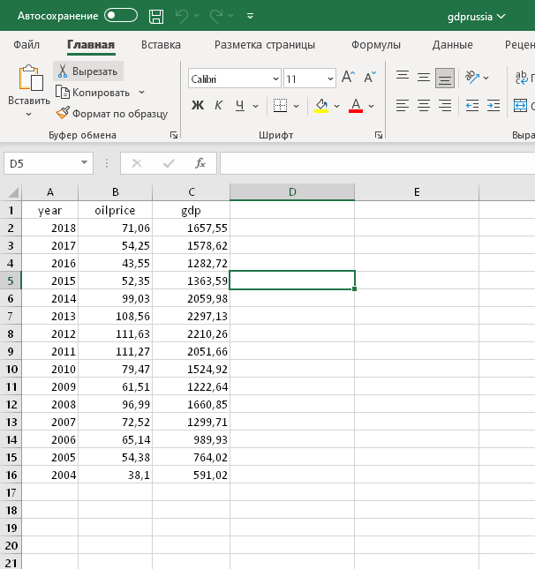

Program that predicts GDP depending on different oil prices

So, here we have data as a graph, train the model with a linear regression algorithm and

predictions of GDP depending on different oil prices, especially:

reg.predict(df[['year','oilprice']])

Predictions for 2025 with oils old prices :100,120,150,170,200

reg.predict([[2025,100]]) predicted GDP is: 2682,9

reg.predict([[2025,120]]) predicted GDP is: 3011,83

reg.predict([[2025,150]]) predicted GDP is: 3505,24

reg.predict([[2025,170]]) predicted GDP is: 3834,17

reg.predict([[2025,200]]) predicted GDP is: 4327,57

Predictions for 2025 with oils old price - 120:

reg.predict([[2020,120]]) predicted GDP is: 2739,55

All predictions you can see on 3rd screenshot

Tasks files uploaded on my GitHub:

https://github.com/spreengg/python-Kanatuly-Zhalgas.git